
Form 1 Integrated Science
Language Exercise

Class: Class No. Name:
3.2 A New Life is Born (1)
A. Vocabularies: copy the vocabularies five times in the boxes below.
reproduce |  |  |  |  |  | 生殖
asexual reproduction |  |  |  |  |  | 無性生殖
sexual reproduction |  |  |  |  |  | 有性生殖
sex cells |  |  |  |  |  | 性細胞
fusion |  |  |  |  |  | 融合
sperms |  |  |  |  |  | 精子
eggs |  |  |  |  |  | 卵
male reproductive system |  |  |  |  |  | 男性生殖系統
testes |  |  |  |  |  | 睪丸
scrotum |  |  |  |  |  | 陰囊
sperm ducts |  |  |  |  |  | 輸精管
urethra |  |  |  |  |  | 尿道
penis |  |  |  |  |  | 陰莖
sex glands |  |  |  |  |  | 性腺體
sex hormones |  |  |  |  |  | 性激素
semen |  |  |  |  |  | 精液


B. Fill in the blanks: choose the suitable vocabularies in p. 1 and complete the sentences below.

(1) ____________________ reproduction does not involve sex cells but ____________________ reproduction involves the fusion of a male sex cell and a female sex cell.

(2) Label the structure of the male reproductive system shown in the diagram below.
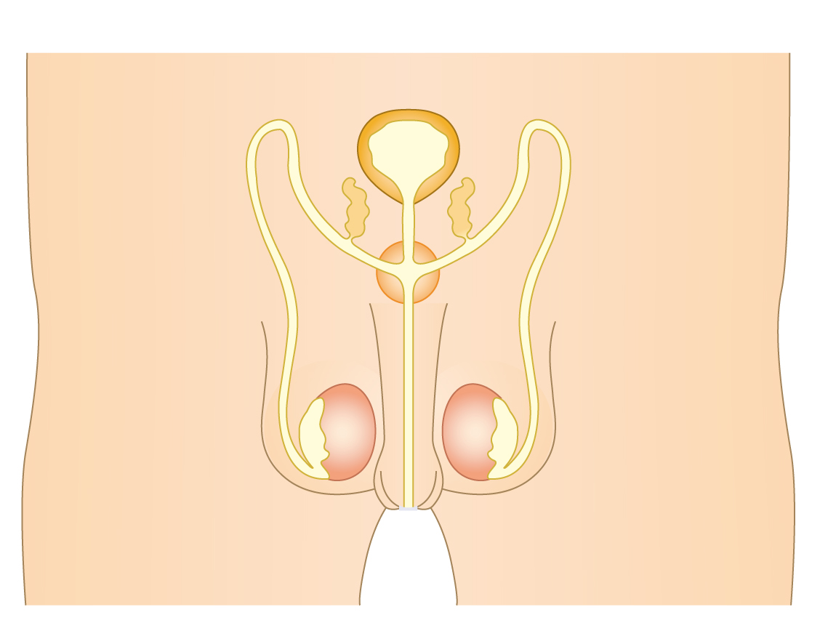

(3) The functions of testes are to produce ____________________ and ____________________ ____________________.

(4) The function of ____________________ ____________________ is to carry sperms from the testes to the urethra.

(5) The function of ____________________ ____________________ is to produce sex hormones and a fluid containing nutrients (養份) for the sperms. This fluid and the sperms form the ____________________.

(6) The function of ____________________ is to carry semen to the female reproductive system during sexual intercourse (性交).

